**IP Header**

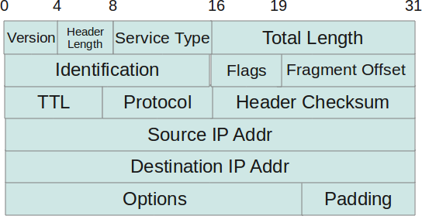

**Version:**

This is 4 bit field which represents IP Protocol version. For IPV4, this value is 4.

**Header Length:**

This is 4 bit field which represents the length of the IP Header in multiples of 32 bit words.

**Type Of Service(TOS):**

The Type Of Service (TOS) field is used to describe the desired quality of service for an IP datagram by upper layer protocols like **TCP**. This field can be used to specify **the nature and priority of a IP datagram** (like Network Control, Immediate, Critical, etc) and **the criteria for selecting a path** for forwarding a datagram by a gateway.

**Note:** They are usually not used.

IP itself does not have any QoS. The fields are to facilitate QoS, but QoS is not a part of IP.

You define the QoS on your network to have the policies that you want **as routers may not have such configuration**. Everyone has a different view of how QoS should be implemented, and that is why QoS doesn't work over the **public Internet**.

**Total Length:**

This is 16 bit field which represents the length of the entire datagram in bytes, including the header and the payload.

**Identification:**

This is 16 bit field which represents the current IP datagram identifier.

**Flags:**

This is 3 bit field which mainly intended to use for Fragmentation.

Bit 0: Reserved |

Bit 1: 0 - Allow fragment, 1 - Don't fragment. |

Bit 2: 0 - Last fragment, 1 - More fragments.

**Fragment Offset:**

This is 13 bit field which specifies the offset in the original IP datagram, where this fragment begins. This is a multiple of 32 bit words.( means Each fragment size will be in multiple of 32 bit words ).

**Time to Live(TTL):**

It is possible for an IP packet to roam aimlessly around the Internet. If there is a routing problem or a routing loop, then you don't want packets to be forwarded forever. A routing loop is when a packet is continually routed through the same routers over and over. The TTL field is initially set to a number and decremented by every router that is passed through. When TTL reaches 0 the packet is discarded. Generally TTL field value is 32 or 64.

**Protocol:**

This is 8 bit field which represents the upper layer protocol number ( 6 for UDP, 17 for TCP).

When the IP packet contain TCP data the protocol number field will have the value **6** in it, so the payload will be sent to the **TCP stack**, TCP would then use the port numbers to send the data to the correct application. The same is **for UDP with protocol number 17.**

Another way to look at the IP protocol number field is, if we didn't have this field in the IP packet header, **IP would only be capable of carrying one type of data**, while adding this field allowed the IP to carry multiple types of data differentiated by the protocol number, the same goes for TCP/UDP using TCP/UDP ports to serve multiple applications.

Example:  for ICMP, 6 for TCP, 17 for UDP, 51 for AH, 88 for EIGRP, 89 for OSPF.

**Header Checksum:**

A value calculated based on the **contents of the IP header**. Used to determine if any errors have been introduced in IP Header during transmission(It is not the checksum for entire IP Datagram as upper layers calculating their own checksum for their data (TCP)).

**Source IP Address:**

This is 32 bit field which stores the 32 bit IP Address of the Sender.

**Destination IP Address:**

This is 32 bit field which stores the 32 bit IP Address of the intended recipient.

**Options and Padding:**

A field that varies in length from 0 to a multiple of 32 bits. If the option values are not multiple of 32 bits , 0 s are added or padded to ensure this field contains a multiple of 32 bits.( Note because header length can only represented in multiple of 32 bits).

Generally options are timestamps, security, source routing, etc.